Service Request Coordinator
(SRC) Strategy

for the

Government of Alberta
Revision History
Updates from June 12, 2008 Version

Name | Date | Sections Changed
Ayumi Takizawa | October 17, 2012 | Updated SILT hyperlink.
Christy Perry | April 14, 2011 | Added update re: forms automation; updated appendices B, C, and D; added section about the software inventory lookup tool (SILT)
Christy Perry | September 16, 2009 | Corrected Level 2 numbered bullets
Christy Perry | September 14, 2009 | Added standards sign-off to Implementation Strategy (section 8)
Christy Perry | September 14, 2009 | Updated information in section 5.2 (automated SR process) with automated service request solution project
Christy Perry | September 14, 2009 | Clearly defined in section 3.3 that the SRC role is to be a Ministry resource
Christy Perry | September 14, 2009 | Aligned Executive Summary (section 1) and SRC Process (section 4) with SRC Committee approved SRC Role Summary
Christy Perry | September 14, 2009 | Changed headers and footers; updated process flow in Appendices C & D; replaced CSD or Consolidated Service Desk with GoA Service Desk
Christy Perry | December 15, 2008 | 5.0 Service Request Forms (updated)
Christy Perry | December 15, 2008 | 5.1 Manual Forms (updated to read “Manual Process – Current State; content updated)
Christy Perry | December 15, 2008 | 5.2 Electronic Forms (updated to read “Automated Process – Future State; content updated)
Christy Perry | December 15, 2008 | 6.1 GoA SRC SharePoint Site (updated link)
Christy Perry | December 15, 2008 | 8.4 Access to Forms, Tools, and Resources (updated)
Christy Perry | December 15, 2008 | Appendix B – SRC Cheat Sheet (updated)
Christy Perry | December 15, 2008 | Appendix C – SRC Submission Process (updated)
Christy Perry | August 14, 2008 | 1.0 Executive Summary (updated)
Christy Perry | August 14, 2008 | 3.1 In Scope (updated)
Christy Perry | August 14, 2008 | 3.2 Out of Scope (updated)
Christy Perry | August 14, 2008 | 3.3.3 Combined Approach (updated)
Christy Perry | August 14, 2008 | 4.1 Coordinating Service Requests (updated)
Christy Perry | August 14, 2008 | 4.2 Submitting Service Requests (updated)
Christy Perry | August 14, 2008 | 4.3 Tracking Service Requests (updated)
Christy Perry | August 14, 2008 | 4.4 Escalating Service Requests (updated)
Christy Perry | August 14, 2008 | 4.5 Acquisition Quotes (removed)
Christy Perry | August 14, 2008 | 4.6 Inventory Information (removed)
Christy Perry | August 14, 2008 | Appendix D (updated)
Christy Perry | June 12, 2008 | Refinement of First Draft
Christy Perry | March 20, 2008 | Document Created – First Draft
William Agbakoba | April 28, 2012 | Document Review- First Draft

Table of Contents

1. Executive Summary 5
2. Document Scope 6
3. SRC Role 7
3.1. In-Scope Responsibilities 7
3.2. Out-of-Scope Duties 7
3.3. Types of SRCs 7
3.3.1. Centralized SRCs 8
3.3.2. Decentralized SRCs 8
3.3.3. Combined Approach 8
3.4. Current Ratios 8
3.5. Working with other Teams 8
4. SRC Processes 9
4.1. Coordinating Service Requests 9
4.2. Submitting Service Requests for Completion 9
4.3. Tracking Service Requests from Start to Finish 10
4.4. Escalating Service Requests 10
5. Service Request Forms 11
5.1. Manual Process – Current State 11
5.1.1. Forms 11
5.1.2. Email Templates 12
5.2. Automated Process – Future State 12
6. Tools & Resources 14
6.1. SRC GOA SharePoint Site 14
6.2. Certified SMS Package List 14
6.3. Certified Hardware List 14
6.4. ITSM - Remedy Website 15
6.5. GOA ADS and External ADS Search Forms 15
6.6. Software Inventory Lookup Tool (SILT) 17
6.7. Wireless Products and Services 17
6.8. SRC Shared Mailbox 18
6.9. GOA Online Catalogue 18
7. Meetings 19
7.1. SRC Ministry Committee Meeting 19
7.2. GOA Cross Government SRC Committee Meetings 19
8. Implementation Strategy 20
8.1. Introduction to the SRC Role 20
8.2. SRC List and Single Point of Contact 20
8.3. SRC Training 20
8.4. Access to Forms, Tools, and Resources 20
8.5. Communication Plan 20
8.6. Standards Sign-Off 20
Appendix A - Roles and Responsibilities 21
8.7. Service Desk Analyst 21
8.8. Desktop Security and Standards 21
8.9. WSP Desktop (Deskside) Analyst 21
8.10. Domain Administration 21
8.11. Exchange Operations 21
8.12. Storage Operations 21
8.13. SMS Package Certification / Creation / Distribution 22
8.14. Network Print Services 22
8.15. Network Operations 22
8.16. Remote Access Services 22
8.17. Procurement and Asset Management Services 22
8.18. Facility Services 22
Appendix B – SRC Cheat Sheet 23
Appendix C – SRC Submission Process Flowchart 27
Appendix D – User Initiated Escalation Process Flowchart 28

Executive Summary

The purpose of this strategy is to outline the desired target state for the Service Request Coordinator (SRC) role across the Government of Alberta, in order to assist client ministries with developing their own SRC framework.

SRCs (Service Request Coordinators), formerly called ITRs (Information Technology Representatives), are the main contact between the GoA Service Desk and their Ministry. They are responsible coordinating, submitting, and may assist with tracking, and escalating IT Service Requests to the GoA Service Desk on behalf of Government of Alberta employees. A service request involves an install, move, add or change (IMAC) to the IT environment. Examples include creating or deleting network IDs and emails, purchasing and installing software, purchasing and deploying hardware, or providing access to network folders. SRCs act as the GOA Ministry specific authorized approver for such requests. Therefore, any requests received from an SRC are considered approved by the Ministry and will be acted on by the Service Desk and Operational Teams.

The definition of the SRC role and the documentation of all SRC procedures is the responsibility of Service Alberta. However, Service Alberta will work with client Ministries to setup a Cross Government SRC Committee to work together to achieve a standardized SRC process for all of government.

Document Scope

The goals of this document it to discuss the following SRC related information:

- SRC Role
  - In-Scope Responsibilities
  - Out-of-Scope Duties
  - Types of SRCs
  - Current Ratios
  - Working with Other Teams
- SRC Procedures
  - Coordinating Service Requests
  - Submitting Service Requests
  - Tracking Service Requests
  - Escalating Service Requests
- Forms
  - Manual
  - Electronic
- Tools and Resources
  - SRC GOA SharePoint Site
  - Certified SMS Package List
  - Certified Hardware List
  - ITSM-Remedy Website
  - GOA ADS & External ADS Search Forms
  - Wireless Products and Services
  - SRC Mail Enabled Public Folder or Shared Email
  - GOA Online Catalogue
- Meetings
  - SRC Ministry Meeting
  - SRC Cross Government SRC Committee Meeting
- Implementation Strategy
  - Introduction to the SRC Role
  - SRC List and Single Point of Contact
  - SRC Training
  - Access to Forms, Tools, and Resources
  - Communication Plan

SRC Role

In-Scope Responsibilities

SRCs balance the wants of the customer, the internal needs of their Ministry, with the requirements of the Government of Alberta IT Support Services (Provisioning, ICT, Ministry IT Support Teams, etc.).

They are responsible for coordinating IT service requests and submitting them to the GOA Service Desk for processing. A service request involves an install, move, add or change (IMAC) to the standard IT environment. They may also be asked to assist the customer with tracking and escalating their service requests once they have been submitted.

Out-of-Scope Duties

SRCs organize the details (information and approvals) of a service request before submitting it to the GOA Service Desk, but do not perform the action(s) required to complete the request. One or more groups within Service Alberta Technology Services are responsible for completing the task(s) involved.

SRCs are not responsible for submitting incident requests to the GOA Service Desk. Incidents are issues within the IT environment which prevents the user from performing his or her job function.

SRCs are not responsible for coordinating the physical move of equipment from one floor/building to another or for coordinating the install of new network ports. The SRC will, however, submit the service request to disconnect/reconnect equipment for moves, and to activate or deactivate network ports as persons move throughout buildings.

SRCs are not responsible for Asset Management. This includes bar-coding, entering or updating asset records, inventory audits, pulling reports (although the SRC can submit a service request for inventory reports if using SA Asset Management Services), or doing asset surplus.

SRCs coordinate procurement requests, but they are not responsible for the procurement itself. This includes providing quotes (client should be directed to the procurement area), arranging for purchase orders, receiving items, or handling invoices.

Note: Although these duties are not part of the GoA defined SRC role, a part-time SRC can still undertake any of these duties if it is part of their primary job function or if the Ministry chooses to include these as part of the role.

Types of SRCs

Although the SRC role is a requirement by Service Alberta for Ministries transitioning to the GoA Domain, SRCs must be Ministry resources. Such persons will best understand the unique and specific business needs and demands of their individual Ministries. Such requirements are then translated into a standard Service Request with the Ministry specific information, which is then completed following GoA standard processes and procedures by Service Alberta resources.

Centralized SRCs

SRCs can be full-time (doing nothing other than SRC work) or part-time (SRC work plus other unrelated or related responsibilities) resources that look after the needs of all clients within a ministry, no matter what business unit they belong to.

Decentralized SRCs

SRCs can be assigned to look after the clients within a specific business unit or building. Because many business units or building are less than 200 persons, the SRC will be performing this role on a part-time basis while completing other responsibilities.

Combined Approach

A ministry can employee both full and part-time SRCs, depending upon their Ministry needs, or where the Ministry is physically located. Some areas have specialized needs or may be located regionally and therefore may require their own dedicated resources. Others have general needs or may be located centrally and can therefore be satisfied by a pool of centralized SRCs.

Current Ratios

The current ratio for a full-time SRC is 200 to 400 persons, depending on the demands of the Ministry.

Working with other Teams

SRCs may have to work closely with the following groups to provide additional information or answer follow-up questions related to a particular request.

- GoA Service Desk
- Desktop Security and Standards
- Desktop (Deskside) Support
- Domain Administration
- Exchange Operations
- Storage Operations
- SMS Package Certification / Creation
- SMS Distribution
- Network Print Services
- Network Operations
- Remote Access Services
- Procurement and Asset Management Services
- Facility Services
See Appendix A for definition of these roles.

SRC Processes

SRCs will work with their clients to ensure that the end users are provided with the highest quality service for their Service Request needs.

Coordinating Service Requests

See Appendix B for a list of common service requests, their required submission format, and important information required to complete the request.

Coordinating the request involves working to gather information, fill out forms/email templates, and obtain the necessary approvals (e.g., Supervisor, Expenditure Officer, Security Officer, etc.) to complete the service request. This work may be initiated by the user with the SRC only providing final approval and submitting the request to the Desk (see below). The SRC may also do all the preparation to complete the requirements, or both the user and SRC may be involved.

This is a mandatory function of the role. The SRC must follow the procedures as documented on the SRC SharePoint site.

Submitting Service Requests for Completion

Submitting a request involves 2 things:
1). Submitting a Service Request through SRM OR;
2). Submitting non- SRM requests to the Service Desk by means of a Word or Email Template.

1). If an SRC is submitting requests through SRM, then the Request goes straight into the ITSM tool prompting a Change ticket to be created. The SRC receives a CRQ number which tells them that the status of the ticket and this ticket gets routed to the approprtiate support teams who handle the request from that point.

2). If an SRC is submitting a non SRM request (requests that have not been built into SRM), it involves attaching the appropriate forms, information, and approvals and emailing the service request to GOA.ServiceDesk@gov.ab.ca. In doing this, the SRC is approving the ticket to be created, and the work needed to fulfill the request to be started. This may also include answering follow-up questions from the Service Desk or Provisioning teams if what has been submitted is unclear or lacking in detail. Additionally, changes to the request are part of the submission process. This includes information changes, priority changes, and request cancellations. The ticket number must be quoted in these situations.

This is a mandatory function of the role. The SRC must follow the procedures as documented on the SRC SharePoint site.

The GOA Service Desk Analyst receiving the request will review it to ensure that all information has been provided to complete the request. If the request is incomplete, they will advise the SRC as to what information is missing. An incomplete ticket is created and cancelled. Otherwise, they will create the ticket/tasks required for the completion of the request. This generates a ticket submission notification to both the client and SRC.

The Service Delivery group or groups responsible for the completion of the ticket/tasks will review the information required for them to complete their part of the ticket. If something is missing or unclear, they will go back to the SRC for additional information. Once they complete their work, they will close their task. After all tasks are closed, the main tickets will be closed, generating a ticket resolution notification to both the client and the SRC.

See Appendix C for the SRC Submission Process Flowchart.

Tracking Service Requests from Start to Finish

Tracking the request involves following up on the ticket status from start to finish either through direct contact with the Service Desk or through the Remedy-ITSM tool. This is especially critical for when there is a requested deadline for resolution. This will also include providing the client with information about the status of the request, as required or as requested.

This is an optional function of the role. Some ministries put this responsibility on the user.

Escalating Service Requests

Escalating the request involves contacting the Service Desk to achieve the desired end result should a service request not be completed to the client’s satisfaction. This may involve escalating a request which is past the scheduled end date or a request which was completed incorrectly.

This is an optional function of the role. Some ministries put this responsibility on the user.
See Appendix D for the User-Initiated Escalation Process Flowchart.

Service Request Forms

Standardized forms need to be used and submitted by all SRCs. A standard submission format used by all gives the GOA Service Desk the opportunity to know what to look for and where to look for it so that they can create an ITSM - Remedy ticket with the correct tasks and tasks assignments.

The “Procedures” section of the SRC SharePoint site (Home - Service Request Coordinator) will state whether or not a form is available, in addition to what form is required. It also provides a link to the form, an associated sample form, as well as an email template when a form is not available.

Manual Process

The current state of the Service Request Submission Process involves the SRC to email a form or text-based email to the Service Desk. The Service Desk then extracts the information from the form to manually create the appropriate ticket and associated tasks.

There are several “parent” forms available to compile the information to complete the service request, each containing options for various types of requests. In instances when a form is not available, an email template must be filled in and submitted, containing the pertinent information to have the request completed.

Forms

Some service requests are complex in nature and therefore may require a form to be filled out so that the necessary information to complete the request is not missed or forgotten. Use of these forms is mandatory for a Ministry to be deemed compliant with the SRC process.

These forms include:

- Client Administration
  - Commencements
  - Terminations (Involuntary)
  - Transfers In
  - Transfers Out
  - Transfers Within
  - Name Changes
  - External IDs
  - Special Accounts
  - Account Disables
  - Extended Leaves
  - Secondments
- IT Acquisition Request (purchases)
*for Ministries using Service Alberta Procurement Services
  - Software Licenses
  - Hardware
  - Combined Software and Hardware
- Mobile Computing
  - Citrix
  - VPN
  - OWA
- Printer Device Deployment Form
  - New Printer Queues
  - Replacement/Upgrade Printer Queues
  - Printer Queue Moves
- SMS Package Creation Request
- Hardware Certification Request
- Wireless Telecom (Blackberries) Requisition
*for Ministries using Service Alberta Telecom Services
  - New
  - Local Number Portability
  - Cancel
  - Transfer
  - Upgrade
- Elevated Privileges
  - Addition or removal of .Z Accounts
- Bulk Service Request Spreadsheets

Email Templates

Not all service requests require a form. Email templates are available for requests where no form is available. While the use of email templates is not mandatory, with the exception of hardware and software templates, it is encouraged since the templates lay out exactly what information is required to complete the request. This same information is asked for in the written procedure.

Automated Process – Current State

Choosing the correct form and/or service request type is often confusing for both Customers and SRCs. Additionally, because the forms are in a PDF or a Microsoft Word or Excel format, mandatory field data entry cannot be enforced and requests are often submitted with incomplete information. This same problem can be identified with email only submissions.

A project was initiated in June 2009 to better enable end-users to request authorized services by providing self-serve automated solution.

That Project has metamorphosed into what is today known as the Service Request Management (SRM) system.

It is the goal of Service Alberta to replace the ALL of the manual submission process with an automated process to achieve the following enterprise requirements:

- User-friendly interface to manage end-to-end Service Requests – intelligent and intuitive
- Validation of data input, and reduce number of data input errors
- Work-flow automation – based on ministry’s business processes
- Role based accessibility – end-users, SRCs, approvals, administrators etc.
- Scalable and robust to accommodate growing business requirements
  - Adding service requests
  - Handling bulk requests (same request for multiple users)
  - Handling multiple requests (many requests for a single user)
- Integration with ITSM 7.0

Service Alberta looked at implementing one of the following automated process options:

- Current automated solution used by Transportation – Universal Service Request System (USR)
- BMC Service Request Management (an ITSM add-on)
- Acrodex IMAC Online Tool

The SRC Committee recommended by majority vote (9 to 3 to 2) to implement SRM for IT Service Request submissions, and would like Service Alberta (as an IT service provider) to manage and coordinate the implementation of this solution. The 3 votes were for USR tool and the 2 votes were to abstain.

A decision request reflecting this vote was submitted to Service Alberta Management in January of 2010 by the SRC Committee chair.

After much consideration and intervention of the Client Management and Reporting program, a formal project was initiated in November 2010 to configure and implement the Service Request Management Tool. The end goal is to have the tool in production and rolled out to GoA domain Ministries by June 2011.

The SRM is currently in Production today and is widely used by Service Request Co-ordinators to make Ministry requests.

Tools & Resources

The Coordinator for GOA SRC Services will be responsible for arranging for all SRCs to have the appropriate access to the tools and resources in this section. These tools are important aids in assisting SRCs with putting together their service requests.

SRC GOA SharePoint Site

https://saportal.gov.ab.ca/SiteDirectory/ictsds/sdws/src/default.aspx

Links to service request forms, sample forms, tools and resources, and procedures will be posted on this site in addition to any information pertinent to the SRC's role.

It will be the responsibility of Service Alberta to monitor and update the information on the SRC SharePoint site when deemed necessary. All SRCs are required to visit this site on a regular basis to obtain the most up-to-date GOA procedures, GOA form links, and any additional information.

There are links to all tools and resources listed in this section on this SharePoint site, making it a one-stop shop for information.

Note: A Ministry’s internal SRC processes will have to be tracked and monitored in a location as specified by the Ministry.

Certified SMS Package List

https://saportal.gov.ab.ca/sites/dss/SMS/SoftDist/default.aspx#certified_software_packages

This is a link to the Desktop Software Support Services site where it lists, by Ministry, all software certified and packaged for use for the GOA domain. It will also detail what software requires a license, and what software requires assistance (remote or Deskside) when being installed.

Certified Hardware List

https://saportal.gov.ab.ca/sites/dss/Shared%20Documents/ServicePage.aspx

This is a link to the Desktop and Security Standards site where it lists, by category, all hardware certified for use for the GOA domain.

ITSM - Remedy Website

https://www.itsmprd.gov.ab.ca/arsys/shared/login.jsp

ITSM – Remedy is the platform on which the eMPAC (eManagement of Problem, Assets and Change) application is run. ITSM – Remedy tracks all client incidents, service requests, assets, service levels and any changes involving network, server, firewalls, etc. This application is adaptable to pull any type of report required.

An SRC will use ITSM - Remedy to track the status of a Service Request, and to view a Ministry’s assets. All SRCs should have viewer access to the Change Management and Asset Management modules. No license is required and these modules can be accessed via the ITSM website.

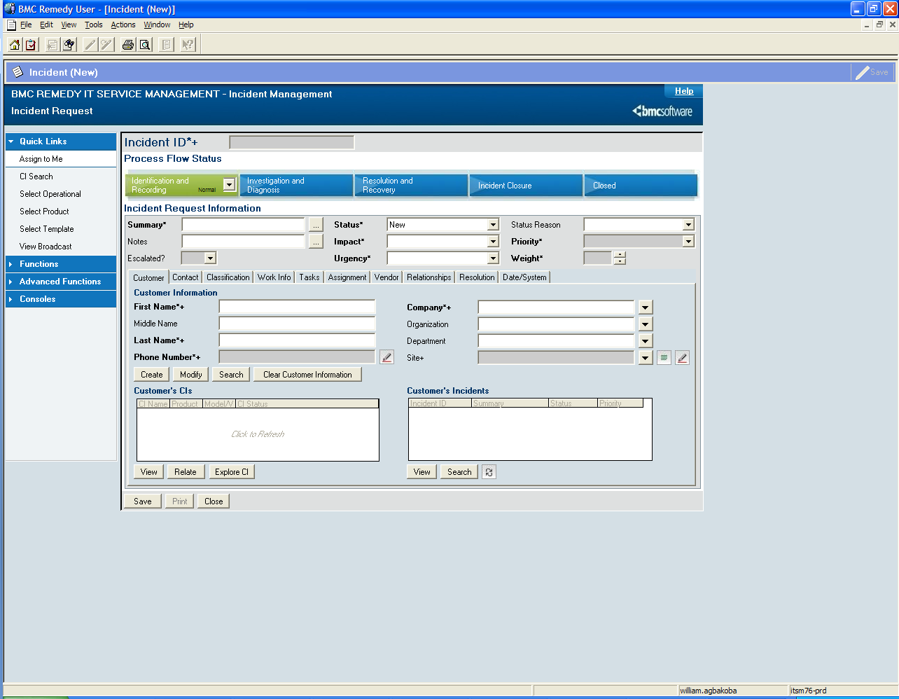

GOA ADS and External ADS Search Forms

https://wln.gov.ab.ca/search/hd2/
https://extern.wln.gov.ab.ca/search/hd2/default.asp?t=hd2

In addition to providing basic user information, the GOA ADS tool can provide a user’s ADS OU (active directory structure organizational unit) information, group memberships, and who controls their Directory Provisioning (GAL) (IMAGIS vs. Domain Administration).

This tool is especially useful for client transfers to verify what ADS OU the client is in, or when a requestor asks for a new employee’s group access to mirror another user.

The External ADS tool is useful for external ID requests in that it will tell you if the person already has an external ID, and what Ministry this external ID is for. It will also provide a reason as to why the external ID was created, as well as show the client’s group memberships.

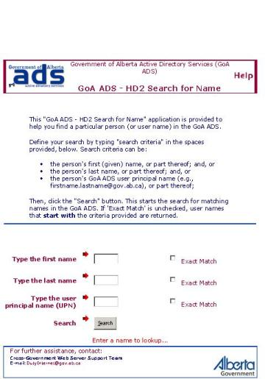
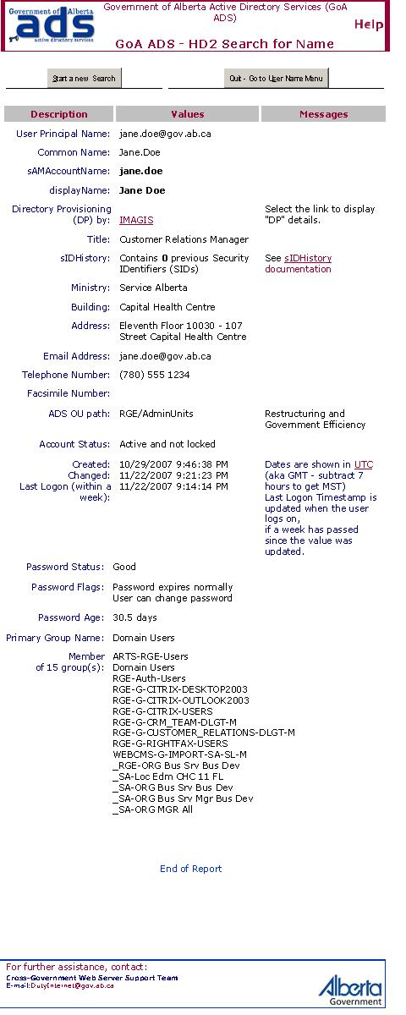

Software Inventory Lookup Tool (SILT)
file://goa/apps/CSU/SILT_v1.4/silt.hta

SILT looks up software on a particular PC and scrubs the list of old drivers, obsolete packages, or packages now part of the base build. It also:

- Alphabetizes the list
- Allows you to save to an Excel file
- Option to Email Software List
- Support/Suggestions Email link
- Copy Shortcut of the tool to your Desktop
- Do not need to be added to a security group

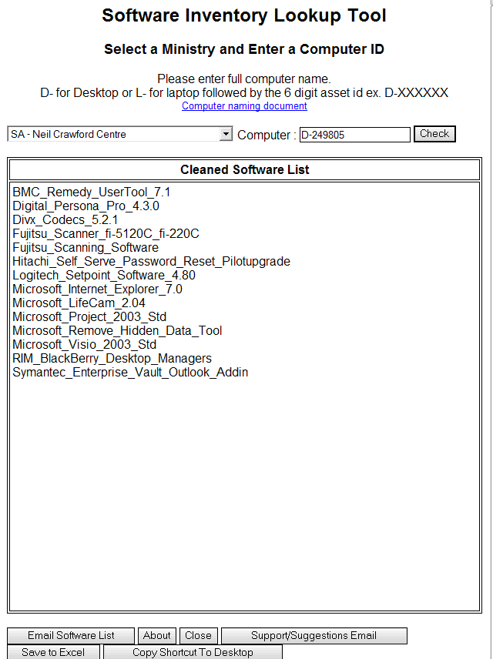

Wireless Products and Services

http://www.servicelink.gov.ab.ca/cellular/

This is a link to the Blackberry vendors, their products (Blackberry models), and services (rate plans).

SRC Shared Mailbox

It is recommended that an SRC Shared Mailbox be created for inquiries from clients, notifications from ITSM, or any IT team involved in the Service Request process. All SRCs need to be given access to this mailbox and the ability to respond to or send from this mailbox. It is not recommended to use an individual’s personal email when performing the SRC role. This is because if the individual SRC is away, the email will not be addressed in a timely manner.

The number of folders or mailboxes depends on the type of SRCs employed within the Ministry. There can be one centralized mailbox, or several mailboxes broken down by purpose or business unit. It is very important that all Ministry SRCs have access to these folders or mailboxes in order to provide cover-off for each other.

The GAL display name and email naming convention should be as follows:

- Ministry Acronym SRC
  - E.g.) SA SRC (SA.SRC@gova.ab.ca)
Service Alberta SRC group
- Ministry Acronym SRC Purpose
  - E.g.) SRD.SRC-Blackberries.M (srd.src-blackberries@gov.ab.ca)
Sustainable Resource Development Blackberry SRC
- Ministry Acronym Business Unit
  - E.g.) JUST SRC Civil Law (just-src2.civil.m@gov.ab.ca)
Justice Civil Law SRCs

Clients should not use these mailboxes to submit incident requests.

GOA Online Catalogue

https://www.myagent.gov.ab.ca

The GOA Catalogue can be used for seeking out hardware and software quotes.

Note: Not all hardware and software is on the standing offer.

The GOA Online Catalogue can be accessed through My Agent. Once signing in, click on the “Purchasing Site” link. The GOA Catalogue link can be found in the section entitled “Standing Offer Contracts”.

Meetings

SRC Ministry Committee Meeting

Ministry SRCs should meet monthly to discuss issues, review existing and/or create new internal procedures and any other information pertinent to the SRC role.

GOA Cross Government SRC Committee Meetings

Service Alberta and client ministry representatives will create a GOA Cross Government SRC Committee.

It is asked that Ministries provide a resource to participate in the GoA Cross Government SRC Committee. This committee will be asked to promote and achieve cross government SRC standardization in the way that Service Request Coordinators coordinate, submit, track, and escalate IT Service Requests. The committee will further be interested in the development of forms and procedures, and the promotion of tools and resources to help achieve the outcome of a common SRC process. The committee will also be concerned with continuous service improvement.

Service Providers may request attendance to or be asked to attend these monthly meetings to discuss their services, and how they relate to SRCs and service requests.

Implementation Strategy

Introduction to the SRC Role

Service Alberta will have an initial “Introduction to the SRC Role” meeting for any Ministry migrating or about to migrate to the GOA domain. They will provide a copy of this strategy, as well as any other documentation that will assist in explaining the function of an SRC.

SRC List and Single Point of Contact

The Ministry needs to provide Service Alberta with a list of their SRCs. A single point of contact needs to be identified as well so that information on the SRC role can be filtered through this individual. This person would then be responsible for sharing this information with their Ministry’s SRCs and representing their Ministry at the monthly SRC Committee meeting.

SRC Training

Service Alberta will provide training to SRCs to discuss the forms and procedures for common Service Requests. This training will also introduce the SRCs to the location of the forms, procedures, and tools and resources for completing Service Requests. This includes a review of the SRC Information Site which includes the following information:

  - Master SRC List for all Ministries
  - Links to Forms
  - Copies of Sample Forms
  - Links to Tools and Resources
  - Documented Procedures
  - Information on the SRC Role

Access to Forms, Tools, and Resources

The Coordinator for GOA SRC Services will provide the link to the SRC SharePoint site, and will work with the Ministry SRC Single Point of Contact to get SRCs access to any tools requiring a security group.

Communication Plan

The Ministry needs to develop a communication plan to inform their Ministry employees on the role of the SRC, and how and when they should be contacted.

Standards Sign-Off

Ministries will be asked to provide official sign-off the SRC role standard, service request information standards, and service request submission standards which have been defined at the SRC Committee. Timelines for providing sign-off can be negotiated after the Ministry has transitioned to the GoA Service Desk.

Appendix A - Roles and Responsibilities

The roles and responsibilities listed in this section are described with regards to how they relate to the SRC role and do not include all aspects of the position.

Service Desk Analyst

The GOA Service Desk is responsible for receiving service request approvals from the SRCs. They create ITSM - Remedy tickets with the correct tasks assigned to the appropriate service delivery teams. They are also the first-point-of-contact for the SRC for any follow-up information or questions on the service request(s).

Desktop Security and Standards

This group is responsible for creating the GOA base computer build, certifying hardware, and updating and creating drivers. They also monitor virus activity.

WSP Desktop (Deskside) Analyst

WSP Deskside Support provides resolution to all incidents and service requests within their assigned building (or group of buildings) by way of ITSM - Remedy cases/tasks. SRCs are the first-point-of-contact for the analyst’s service request ticket or task. Additionally, if it is deemed by the analyst that their incident ticket or task requires a service request element, they will contact the correct SRC to submit the request.

SRCs and WSP Deskside Analysts are often involved in two-way information sharing to complete a service request and therefore, have a close working relationship.

Domain Administration

Domain Administration is responsible for creating network IDs and email accounts, creating, deleting, and maintaining email distribution lists, and for providing access to and creating network folders.

Exchange Operations

Exchange Operations restores client mailboxes, increases the storage size of email accounts, and adds users to the Blackberry Exchange Server (BES).

Storage Operations

Storage Operations is responsible for network file / directory restores and for increasing the size of a user’s My Documents storage size.

SMS Package Certification / Creation / Distribution

This team is responsible for certifying and creating software packages for use on the GOA domain. The distribution side pushes software packages to user’s PCs.

Network Print Services

Network Print Services creates and maintains printer queues for all network printers on the GOA domain.

Network Operations

Network Operations is responsible for activating GOA network ports and for setting up external internet ports.

Remote Access Services

Remote Access is responsible for GOA Citrix and VPN support and RSA FOB administration.

Procurement and Asset Management Services

Service Alberta Procurement and Asset Management Services is responsible for coordinating (providing quotes, creating Purchase Orders) the acquisition of IT assets with various vendors. The equipment will be shipped to their warehouse, bar-coded and entered into ITSM - Remedy, and then shipped to the appropriate Deskside area for deployment.

Note: Not all GOA ministries use this service.

Facility Services

Facility Services coordinates bulk equipment moves (floor to floor or building to building) and for the installation of new network ports. Costs for such services are above the negotiated Schedule C pricing.

Note: Not all GOA ministries use this service.

Appendix B – SRC Cheat Sheet

Please refer to document: SRM REQUEST LISTING- IF AUTOMATED.

https://saportal.gov.ab.ca/SiteDirectory/ictsds/sdws/src/default.aspx

Appendix C – SRC Manual Submission Process Flowchart

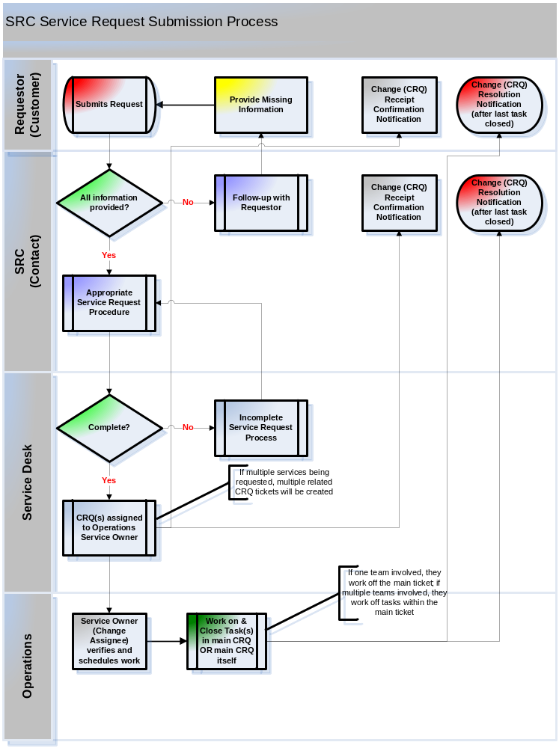
Appendix D – User Initiated Escalation Process Flowchart



